**Deep-Learning**

# Practical 4

**Aim : Basics of Tensorflow for Nueral network**

Code:

import numpy as np import tensorflow as tf

from tensorflow.keras import layers, models

# Step 1: Create a small dataset

x_train = np.array([[0.1, 0.2], [0.4, 0.3], [0.5, 0.6], [0.9,

0.8], [0.7, 0.3],

[0.2, 0.1], [0.8, 0.5], [0.4, 0.6], [0.3,

0.7], [0.6, 0.9]]) y_train = (x_train[:, 1] > x_train[:, 0]).astype(int)

# Step 2: Define the Model model = models.Sequential([

layers.Dense(8, activation='relu', input_shape=(2,)),

layers.Dense(1, activation='sigmoid')

])

# Step 3: Compile the Model model.compile(optimizer='adam', loss='binary_crossentropy', metrics=['accuracy'])

# Step 4: Train the Model

model.fit(x_train, y_train, epochs=5, batch_size=2)

# Step 5: Make Predictions predictions = model.predict(x_train) print("Predictions (rounded):", np.round(predictions).astype(int)) print("Actual Labels:", y_train)

# Step 6: Evaluate the Model

test_loss, test_acc = model.evaluate(x_train, y_train) print(f'Test Accuracy: {test_acc}')

# To visualize the model structure model.summary()

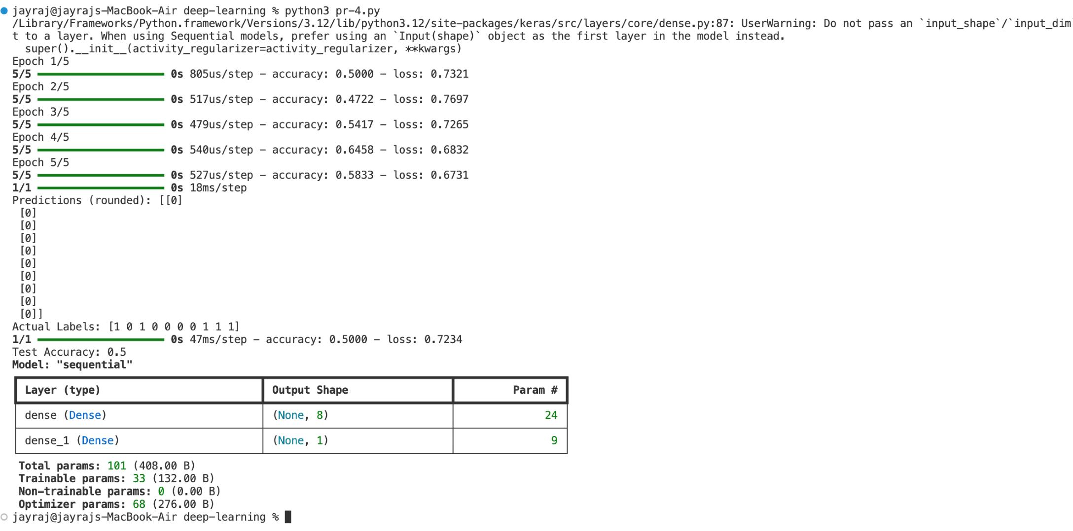Output

# Practical 5

**Aim : Write a python program to implement perceptron using tensorflow** Code:

import numpy as np import tensorflow as tf

from tensorflow.keras import layers, models

x_train = np.array([[0, 0], [0, 1], [1, 0], [1, 1]]) y_train = np.array([[0], [0], [0], [1]])

model = models.Sequential([

layers.Dense(1, activation='sigmoid', input_shape=(2,))

])

weights = np.array([[0.4], [0.6]]) bias = np.array([0.2])

# Set weights and bias for the Dense layer model.layers[0].set_weights([weights, bias])

model.compile(optimizer='adam', loss='binary_crossentropy', metrics=['accuracy'])

# Train the model

model.fit(x_train, y_train, epochs=5)

# Make predictions

predictions = model.predict(x_train) print("Predictions (rounded):", np.round(predictions).astype(int)) print("Actual Labels:", y_train)

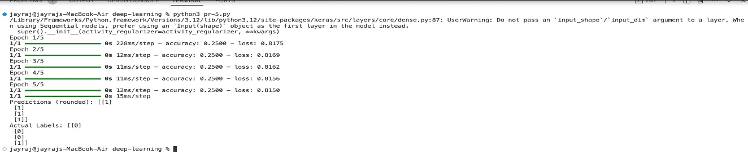Output:

**Practical 6**

**Aim : Write a program to implement an autoencoder for image reconstruction**

**Code:**

import numpy as np import os

import matplotlib.pyplot as plt from tensorflow.keras import layers, models import pandas as pd

def load_fashion_mnist_data():

base_path = './fashion-mnist/'

# Load data directly if CSV format is provided x_train = pd.read_csv(os.path.join(base_path, 'fashion-

mnist_train.csv')).values[:, 1:] / 255.0

x_test = pd.read_csv(os.path.join(base_path, 'fashion-

mnist_test.csv')).values[:, 1:] / 255.0 return x_train, x_test

x_train, x_test = load_fashion_mnist_data() encoding_dim = 64

input_img = layers.Input(shape=(784,))

encoded = layers.Dense(encoding_dim, activation='relu')

(input_img) decoded = layers.Dense(784, activation='sigmoid')(encoded)

# Combine encoder and decoder into the autoencoder model autoencoder = models.Model(input_img, decoded)

autoencoder.compile(optimizer='adam', loss='binary_crossentropy')

autoencoder.fit(x_train, x_train, epochs=5, batch_size=256, shuffle=True,

validation_data=(x_test, x_test))

# Encode and decode some images (reconstruction) decoded_imgs = autoencoder.predict(x_test)

# Reshape images back to 28x28 for visualization

decoded_imgs = decoded_imgs.reshape((x_test.shape[0], 28, 28))

n = 10

plt.figure(figsize=(20, 4)) for i in range(n):

# Display original images ax = plt.subplot(2, n, i + 1)

plt.imshow(x_test[i].reshape(28, 28), cmap='gray')

ax.get_xaxis().set_visible(False) ax.get_yaxis().set_visible(False)

# Display reconstructed images

ax = plt.subplot(2, n, i + 1 + n) plt.imshow(decoded_imgs[i], cmap='gray') ax.get_xaxis().set_visible(False) ax.get_yaxis().set_visible(False) plt.show() Output:- 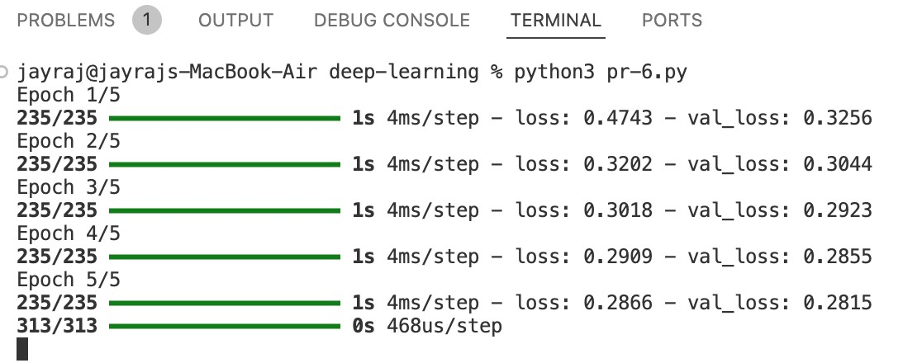

original images

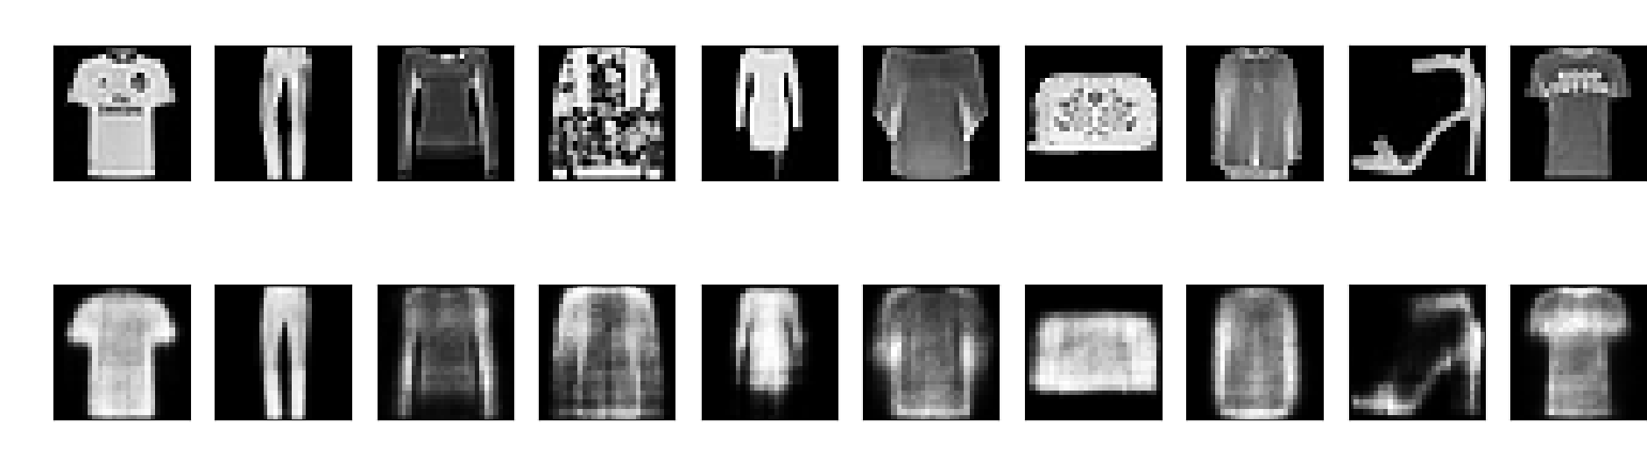

reconstructed images

# Practical 7

**Aim :Write a program in python for image classification using CNN (using tensorflow.**

Code

import numpy as np import os

import matplotlib.pyplot as plt

import pandas as pd import tensorflow as tf

from tensorflow.keras import layers, models

# Load the Fashion MNIST dataset def load_fashion_mnist_data():

base_path = './fashion-mnist/'

x_train = pd.read_csv(os.path.join(base_path, 'fashion-

mnist_train.csv')).values[:, 1:]

x_test = pd.read_csv(os.path.join(base_path, 'fashion-

mnist_test.csv')).values[:, 1:]

# Reshape data to 28x28 and scale to [0, 1] x_train = x_train.reshape(-1, 28, 28, 1) / 255.0 x_test = x_test.reshape(-1, 28, 28, 1) / 255.0

# Extract labels

y_train = pd.read_csv(os.path.join(base_path, 'fashion-

mnist_train.csv')).values[:, 0]

y_test = pd.read_csv(os.path.join(base_path, 'fashionmnist_test.csv')).values[:, 0] return x_train, y_train, x_test, y_test

x_train, y_train, x_test, y_test = load_fashion_mnist_data()

model = models.Sequential([

layers.Conv2D(32, (3, 3), activation='relu',

input_shape=(28, 28, 1)), layers.MaxPooling2D((2, 2)),

layers.Conv2D(64, (3, 3), activation=‘relu'), layers.MaxPooling2D((2, 2)),

layers.Conv2D(64, (3, 3), activation='relu'),

layers.Flatten(),

layers.Dense(64, activation='relu'),

layers.Dense(10, activation='softmax') # 10 classes for

Fashion MNIST

])

model.compile(optimizer='adam',

loss='sparse_categorical_crossentropy', metrics=['accuracy'])

model.fit(x_train, y_train, epochs=5, batch_size=300, validation_split=0.1)

test_loss, test_acc = model.evaluate(x_test, y_test) print('Test accuracy:', test_acc) predictions = model.predict(x_test)

def plot_predictions(x, y_true, y_pred, class_names): plt.figure(figsize=(10, 10)) for i in range(25): plt.subplot(5, 5, i + 1)

plt.imshow(x[i].reshape(28, 28), cmap='gray') plt.title(f"True: {class_names[y_true[i]]}\nPred:

{class_names[np.argmax(y_pred[i])]}")

plt.axis('off') plt.tight_layout() plt.show()

# Define class names for Fashion MNIST

class_names = ['T-shirt/top', 'Trouser', 'Pullover', 'Dress',

'Coat',

'Sandal', 'Shirt', 'Sneaker', 'Bag', 'Ankle boot']

# Plot the predictions

plot_predictions(x_test, y_test, predictions, class_names)

Output

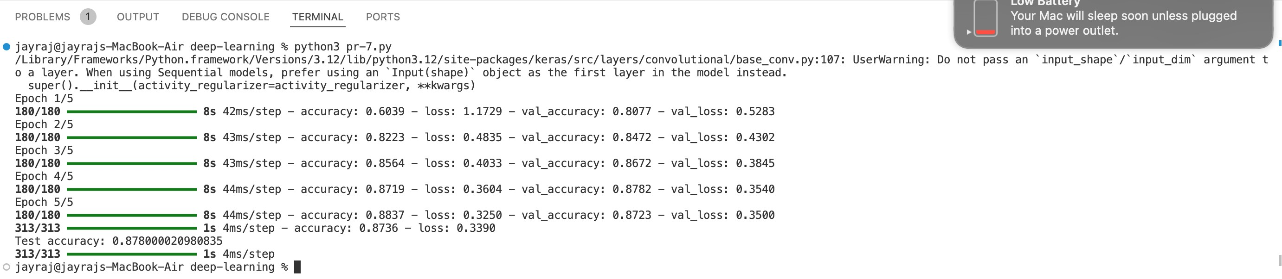

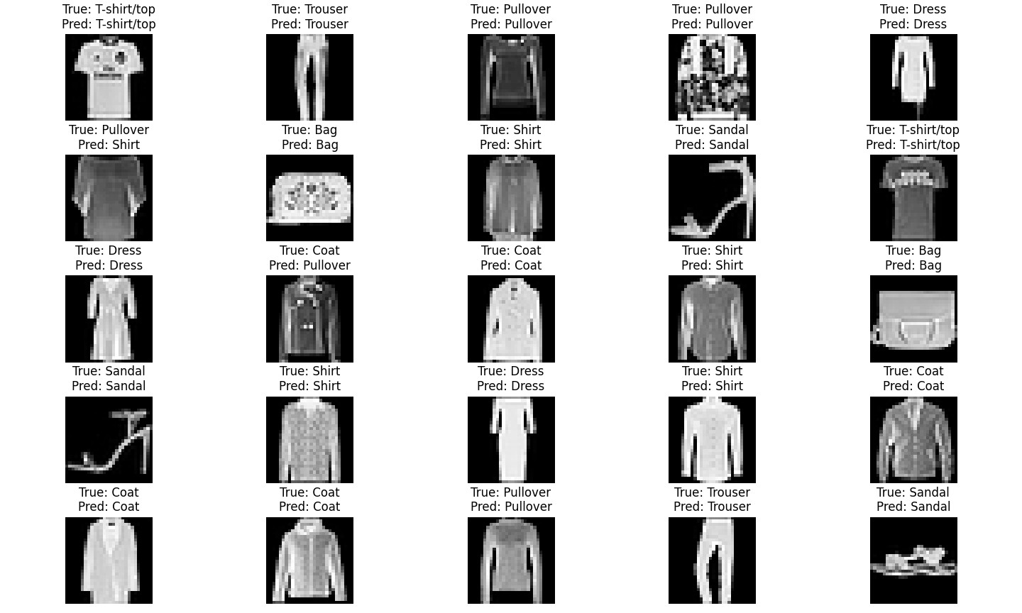

# Practical 8

**Aim : Write a program to use a pre-trained model (e.g., VGG16, Reset) for a custom image classification task. Code:-**

from google.colab import files uploaded = files.upload()

import keras

from keras.applications.resnet50 import ResNet50 from keras.applications.resnet50 import preprocess_input, decode_predictions import numpy as np

from keras.applications.resnet50 import ResNet50

# Load the pre-trained ResNet50 model model = ResNet50(weights='imagenet')

img_path= 'Camera.jpg'

img = keras.utils.load_img(img_path, target_size=(224, 224))

x= keras.utils.img_to_array(img) x = np.expand_dims(x, axis=0) x = preprocess_input(x) preds = model.predict(x) print('Predicted:', decode_predictions (preds, top=3) [0]) **Output:-**

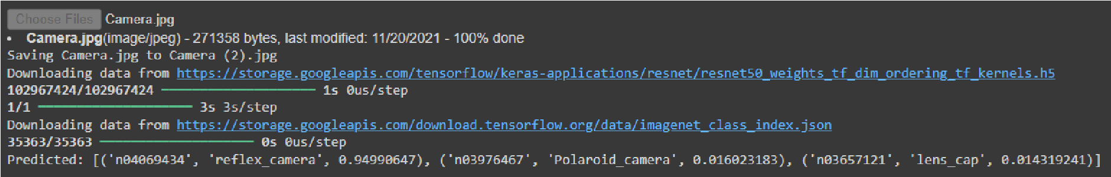

# Practical 9

**Aim : Write a program to fine-tune the pre-trained model on a new dataset and Compare the performance of the fine-tuned model with a model trained from scratch. Code:-**

import os import zipfile import numpy as np import pandas as pd

from tensorflow.keras.models import Sequential from tensorflow.keras.layers import Dense from sklearn.model_selection import train_test_split from tensorflow.keras.utils import to_categorical

os.makedirs(os.path.expanduser("~/.kaggle"), exist_ok=True) kaggle_json_path = os.path.expanduser("~/.kaggle/kaggle.json") if not os.path.exists(kaggle_json_path): raise FileNotFoundError("kaggle.json file not found.

Please set up Kaggle API key as described.")

# Download Fashion MNIST dataset from Kaggle os.system('kaggle datasets download -d zalando-research/ fashionmnist')

# Unzip the dataset with zipfile.ZipFile('fashionmnist.zip', 'r') as zip_ref: zip_ref.extractall('fashionmnist')

train_data = pd.read_csv('fashionmnist/fashionmnist_train.csv')

test_data = pd.read_csv('fashionmnist/fashion-mnist_test.csv')

x_train = train_data.iloc[:, 1:].values y_train = train_data.iloc[:, 0].values x_test = test_data.iloc[:, 1:].values y_test = test_data.iloc[:, 0].values

x_train = x_train / 255.0 x_test = x_test / 255.0

# Convert labels to categorical (one-hot encoding)

y_train = to_categorical(y_train, 10) y_test = to_categorical(y_test, 10)

# Split train set into train and validation set x_train, x_val, y_train, y_val = train_test_split(x_train, y_train, test_size=0.2, random_state=42)

# Build the model model = Sequential([

Dense(128, activation='relu', input_shape=(x_train.shape[1],)), Dense(64, activation='relu'),

Dense(10, activation='softmax') # 10 classes for Fashion

MNIST

])

# Compile the model model.compile( optimizer='adam',

loss='categorical_crossentropy',

metrics=['accuracy']

)

# Train the model

model.fit(x_train, y_train, epochs=5, batch_size=32, validation_data=(x_val, y_val))

# Evaluate the model on the test set

test_loss, test_acc = model.evaluate(x_test, y_test) print(f'Test accuracy: {test_acc}')

# Save the model model.save(‘fashion_mnist_model.h5')

**Output:-**

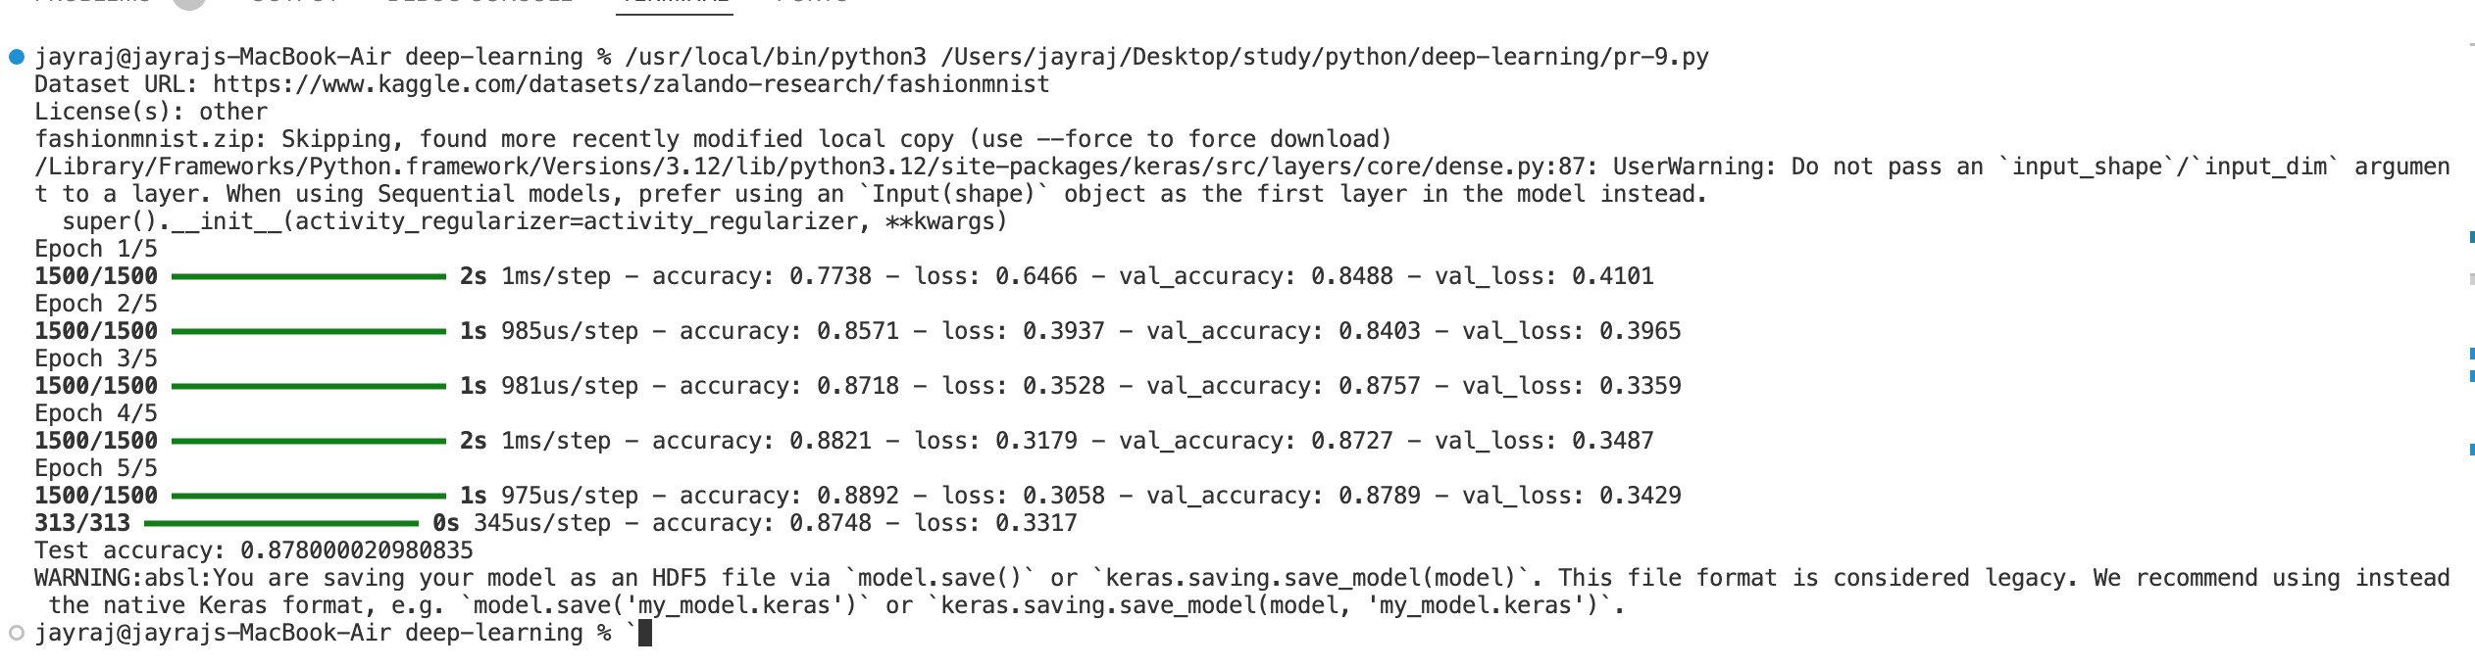

# Practical 10

**Aim : Write a program to implement an RNN/LSTM for text generation. Code:-**

import numpy as np import tensorflow as tf

from tensorflow.keras.models import Sequential

from tensorflow.keras.layers import LSTM, Dense, Embedding, Dropout

from tensorflow.keras.preprocessing.text import Tokenizer from tensorflow.keras.preprocessing.sequence import pad_sequences

text = """The quick brown fox jumps over the lazy dog. The quick brown fox jumps over the lazy dog."""

tokenizer = Tokenizer(char_level=True) tokenizer.fit_on_texts([text]) total_chars = len(tokenizer.word_index) + 1 input_sequences = [] for i in range(1, len(text)): seq = text[:i+1]

input_sequences.append(tokenizer.texts_to_sequences([seq])

[0])

max_sequence_len = max([len(seq) for seq in input_sequences]) input_sequences = pad_sequences(input_sequences, maxlen=max_sequence_len, padding='pre')

input_sequences = np.array(input_sequences)

X = input_sequences[:, :-1] y = input_sequences[:, -1]

y = tf.keras.utils.to_categorical(y, num_classes=total_chars)

# Build the LSTM model model = Sequential() model.add(Embedding(total_chars, 50, input_length=max_sequence_len - 1)) model.add(LSTM(100, return_sequences=True))

model.add(Dropout(0.2)) model.add(LSTM(100))

model.add(Dense(total_chars, activation='softmax'))

# Compile the model

model.compile(loss='categorical_crossentropy', optimizer='adam', metrics=['accuracy'])

# Train the model

history = model.fit(X, y, epochs=5)

# Function to generate text def generate_text(seed_text, next_chars=10): for _ in range(next_chars): tokenized_seq =

tokenizer.texts_to_sequences([seed_text])[0] tokenized_seq = pad_sequences([tokenized_seq], maxlen=max_sequence_len, padding='pre') predicted_char_index =

np.argmax(model.predict(tokenized_seq), axis=-1) next_char =

tokenizer.index_word[predicted_char_index[0]]

seed_text += next_char return seed_text

seed_text = "The quick"

generated_text = generate_text(seed_text, next_chars=20) print("Generated Text: \n", generated_text)

**Output:-**

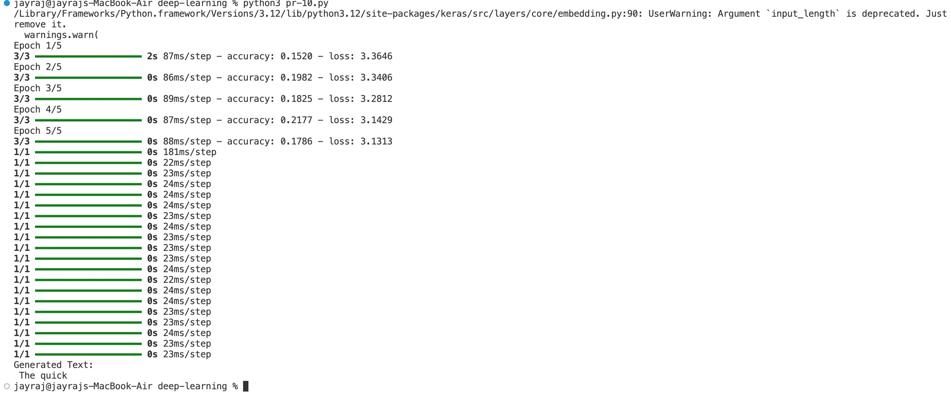

# Practical 11

**Aim : Write a program to train the model on a text corpus (e.g., Shakespeare's works). Code:-**

import numpy as np import tensorflow as tf

from tensorflow.keras.models import Sequential

from tensorflow.keras.layers import LSTM, Dense, Embedding, Dropout

from tensorflow.keras.preprocessing.text import Tokenizer from tensorflow.keras.preprocessing.sequence import pad_sequences

text = """Shall I compare thee to a summer's day?

Thou art more lovely and more temperate:

Rough winds do shake the darling buds of May, And summer's lease hath all too short a date:

Sometime too hot the eye of heaven shines,

And often is his gold complexion dimm'd;

And every fair from fair sometime declines,

By chance or nature's changing course untrimm'd;

But thy eternal summer shall not fade

Nor lose possession of that fair thou owest;

Nor shall Death brag thou wanderest in his shade, When in eternal lines to time thou growest:

So long as men can breathe or eyes can see,

So long lives this, and this gives life to thee."""

tokenizer = Tokenizer(char_level=True) tokenizer.fit_on_texts([text])

total_chars = len(tokenizer.word_index) + 1 # Total unique characters

input_sequences = [] for i in range(1, len(text)): seq = text[:i+1]

input_sequences.append(tokenizer.texts_to_sequences([seq]) [0])

max_sequence_len = max([len(seq) for seq in input_sequences]) input_sequences = pad_sequences(input_sequences, maxlen=max_sequence_len, padding='pre')

input_sequences = np.array(input_sequences)

X = input_sequences[:, :-1] y = input_sequences[:, -1]

y = tf.keras.utils.to_categorical(y, num_classes=total_chars)

# Build the LSTM model model = Sequential()

model.add(Embedding(total_chars, 50, input_length=max_sequence_len - 1)) model.add(LSTM(100, return_sequences=True))

model.add(Dropout(0.2)) model.add(LSTM(100))

model.add(Dense(total_chars, activation='softmax'))

# Compile the model

model.compile(loss='categorical_crossentropy', optimizer='adam', metrics=['accuracy'])

# Train the model

history = model.fit(X, y, epochs=10, verbose=1)

# Function to generate text def generate_text(seed_text, next_chars=100): for _ in range(next_chars): tokenized_seq =

tokenizer.texts_to_sequences([seed_text])[0] tokenized_seq = pad_sequences([tokenized_seq], maxlen=max_sequence_len, padding='pre') predicted_char_index =

np.argmax(model.predict(tokenized_seq), axis=-1) next_char =

tokenizer.index_word[predicted_char_index[0]]

seed_text += next_char return seed_text

seed_text = "Shall I compare"

generated_text = generate_text(seed_text, next_chars=100)

print("Generated Text: \n", generated_text)

**Output:-**

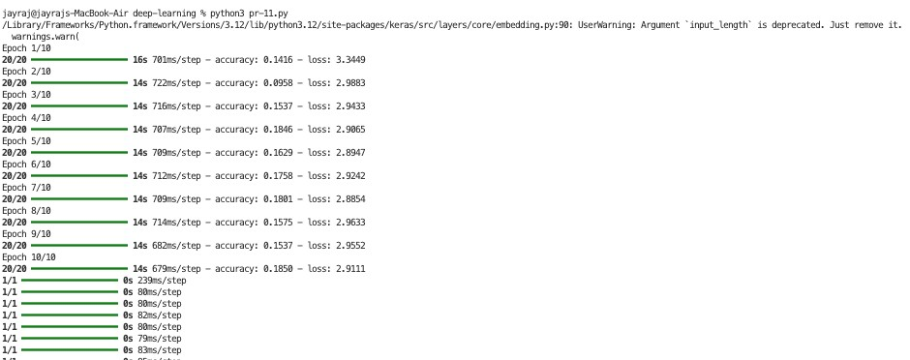

# Practical 12

**Aim : Write a program to implement an RNN/LSTM for sentiment analysis for any text data such as tweets, instagram comment etc. Code:-**

import tensorflow as tf import tensorflow_datasets as tfds from tensorflow.keras.models import Sequential

from tensorflow.keras.layers import Embedding, LSTM, Dense, Dropout

from tensorflow.keras.preprocessing.sequence import pad_sequences

# Load the dataset

dataset, info = tfds.load("imdb_reviews", with_info=True,

as_supervised=True)

train_data, test_data = dataset['train'], dataset['test']

vocab_size = 10000 max_length = 200 embedding_dim = 64 batch_size = 300

train_texts = [] for text, label in train_data: train_texts.append(text.numpy().decode('utf-8')) # Decode from bytes to string

tokenizer =

tf.keras.preprocessing.text.Tokenizer(num_words=vocab_size,

oov_token="<OOV>")

tokenizer.fit_on_texts(train_texts)

def encode_and_pad(text, label): # Tokenize and pad the text

text =

tokenizer.texts_to_sequences([text.numpy().decode('utf-8')])

text = pad_sequences(text, maxlen=max_length,

padding='post', truncating='post')

return tf.convert_to_tensor(text[0], dtype=tf.int32), tf.convert_to_tensor(label, dtype=tf.int64)

def encode_and_pad_tf(text, label): text, label = tf.py_function(func=encode_and_pad, inp=[text, label], Tout=(tf.int32, tf.int64))

text.set_shape([max_length]) label.set_shape([]) return text, label

# Apply the transformation

train_data = train_data.map(encode_and_pad_tf) test_data = test_data.map(encode_and_pad_tf)

# Shuffle, batch, and prefetch the datasets train_data =

train_data.shuffle(10000).batch(batch_size).prefetch(tf.data.e xperimental.AUTOTUNE) test_data =

test_data.batch(batch_size).prefetch(tf.data.experimental.AUTO

TUNE)

# LSTM model model = Sequential([

Embedding(vocab_size, embedding_dim), # Removed

input_length

LSTM(64, return_sequences=True),

Dropout(0.5),

LSTM(32),

Dense(32, activation='relu'),

Dense(1, activation='sigmoid')

])

model.compile(loss='binary_crossentropy', optimizer='adam', metrics=['accuracy'])

steps_per_epoch = len(train_data) // batch_size model.fit(train_data, epochs=5, validation_data=test_data, steps_per_epoch=steps_per_epoch)

loss, accuracy = model.evaluate(test_data) print(f'Test Accuracy: {accuracy * 100:.2f}%’) new_texts = ["This movie was fantastic!", "I did not like the film at all."]

new_sequences = tokenizer.texts_to_sequences(new_texts) new_padded_sequences = pad_sequences(new_sequences, maxlen=max_length, padding='post')

predictions = model.predict(new_padded_sequences) for i, text in enumerate(new_texts): sentiment = "positive" if predictions[i] > 0.5 else

"negative" print(f"Text: {text} | Predicted Sentiment: {sentiment}")

**Output:-**

